Pastor Amos Juma Wafula

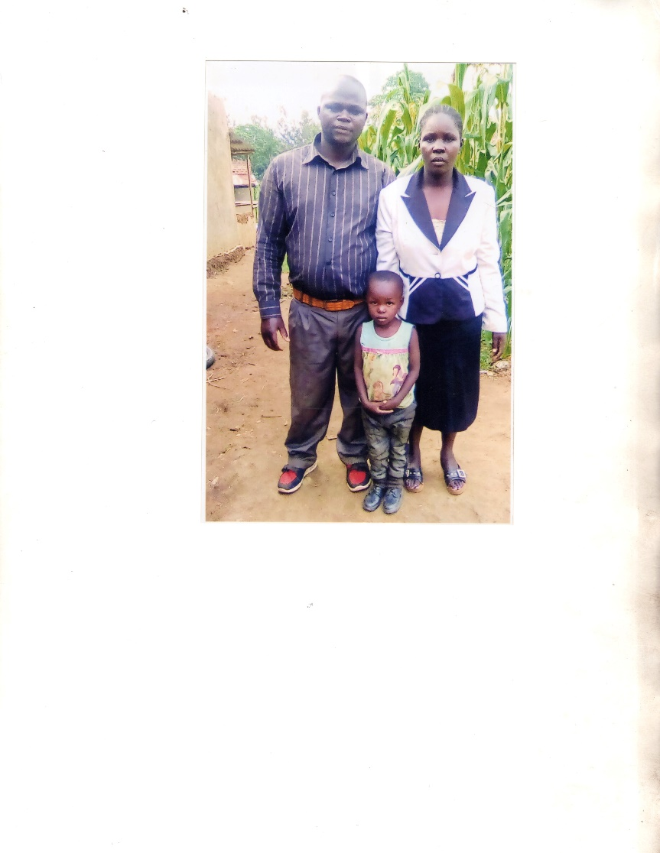

and his wife

Acts 433 Church Kimwanga

Pastor Peter Wanyonyi

and his wife Mercy

Acts 433 Church Kimukung'i

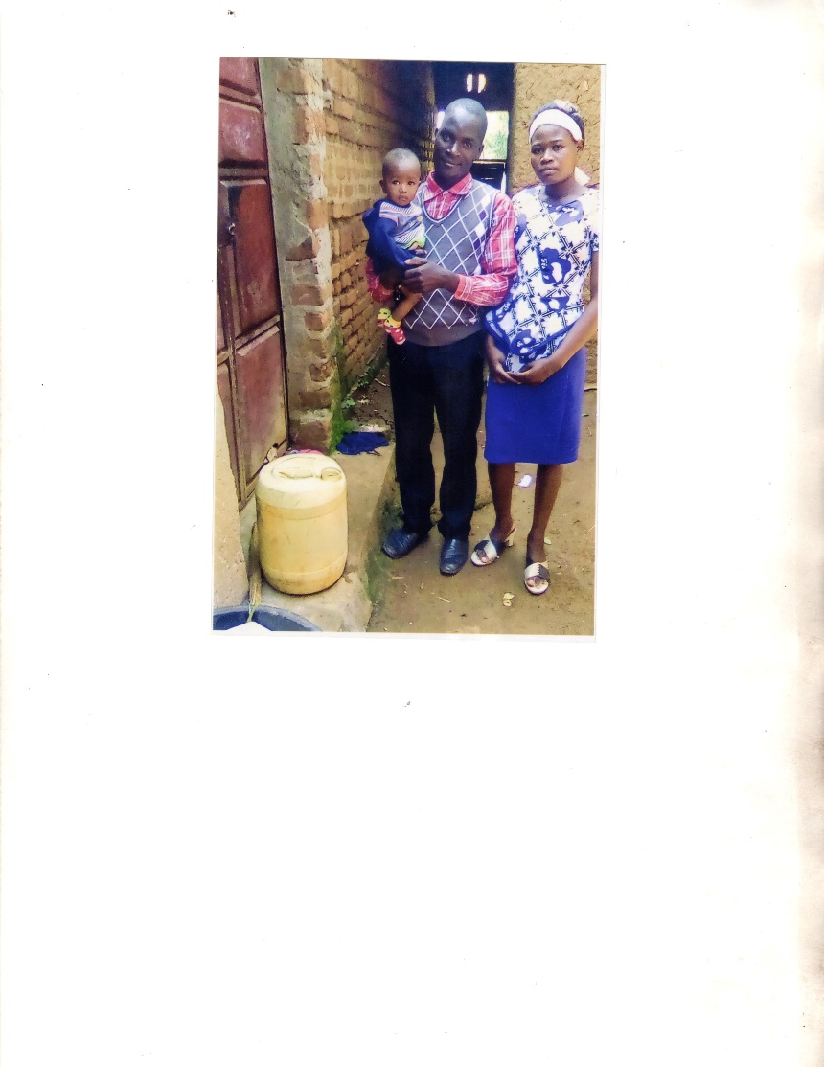

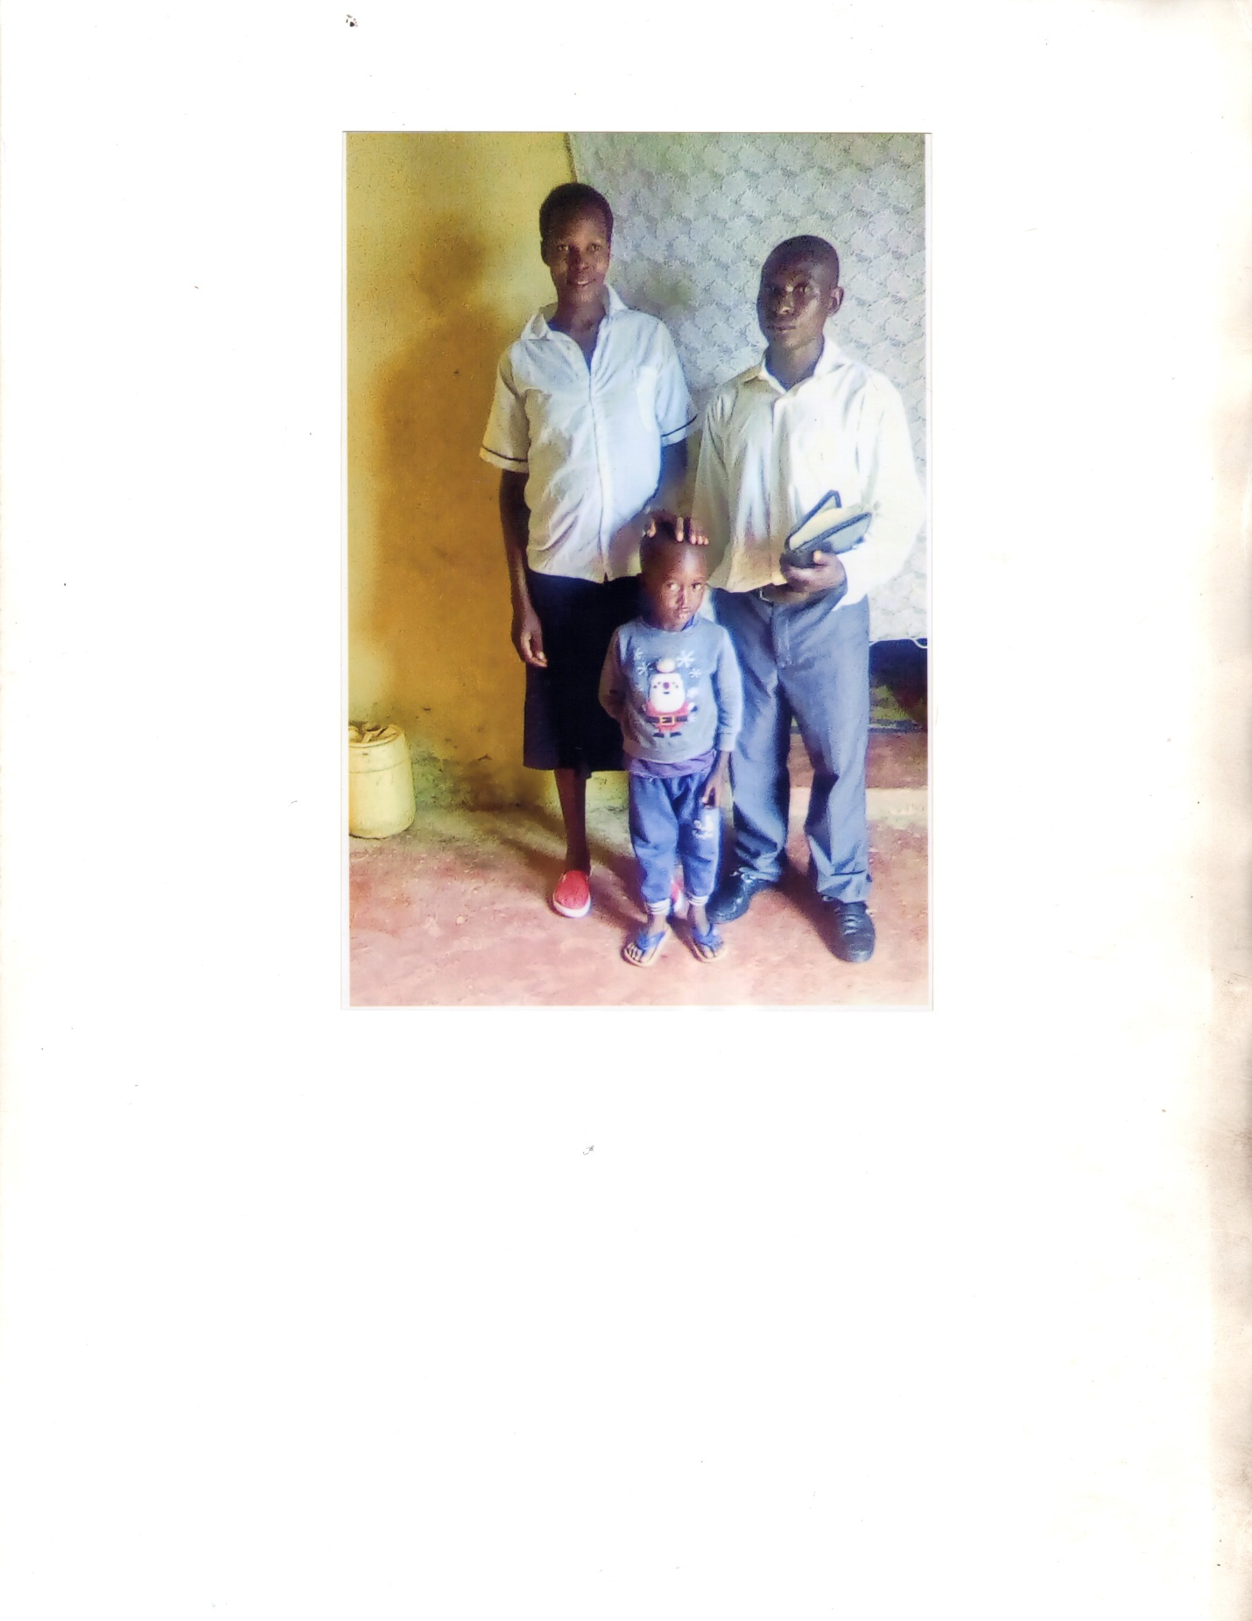

Pastor Allan Waswa and his wife Janet

Acts 433 Church Namikelo

Pastor Geoffrey Wafula

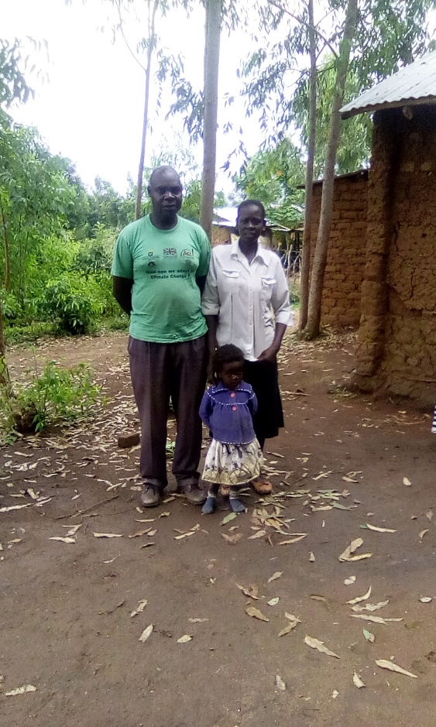

and his wife Josephine

Acts 433 Church Napara

Pastor Oscar Simiyu Wafula

Acts 433 Church Chemche

